**Create AdminList table in Dataverse**

1. Select the Data burger.

1. Select add data and press create new tables

1. Select start from blank

1. Rename the table to AdminList

1. Add a new column. Change display name to Email and format to Email then press save

1. Add new column rename it to First Name

1. Add new column rename it to Last Name

1. Input data for later testing

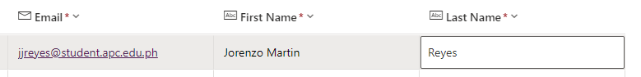

1. Press save and exist

